Pi Mu Epsilon
Problem of the Month
September 2008

To solve this cross-sum puzzle, follow these guidelines:
- The number to the left or above a set of squares is the sum of the digits in those squares.
- No numbers may be repeated in a sum.
- Only the whole numbers 1 through 9 may be used.
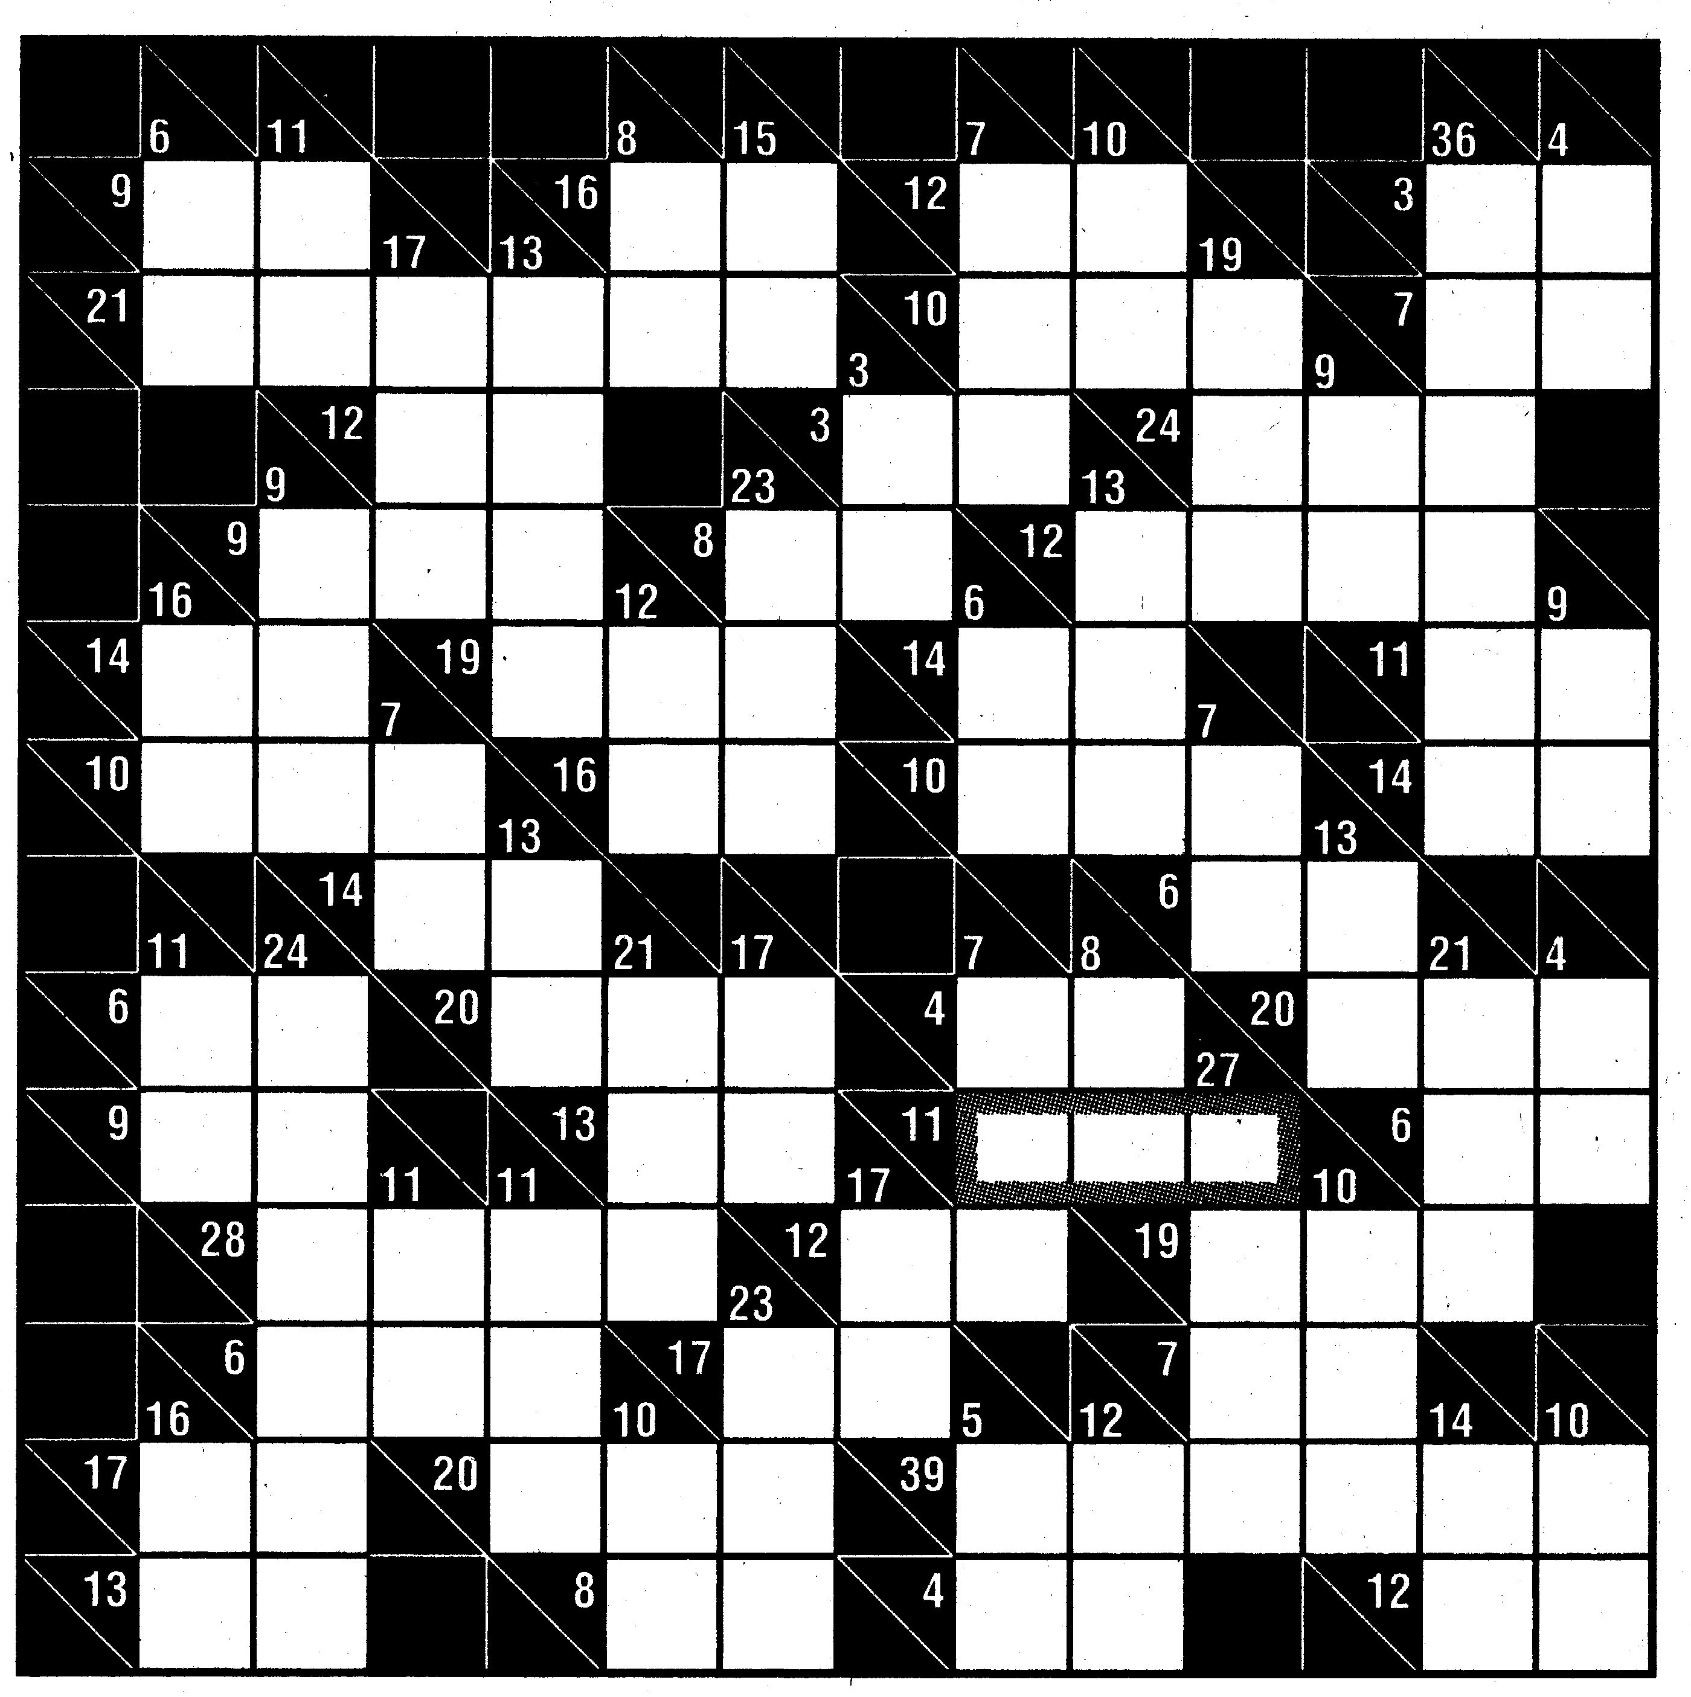

Problem of the Month Rules:
- Submissions must include a complete mathematical justification along with the answer.
- Submissions may only be made by individuals or groups of two and must be dated.
- Submissions for this problem are due before 5 p.m. on September 23, 2008; they may be given to Dr. Leigh Lunsford (Ruffner 331), Dr. Phillip Poplin (Ruffner 335), or Dr. David Shoenthal (Ruffner 344).

Pi Mu Epsilon Problem of the Month website: http://www.longwood.edu/staff/shoenthaldw/potm.html

