STEP 1: SIGN UP
Get a pen

STEP 2: TAKE ACTION
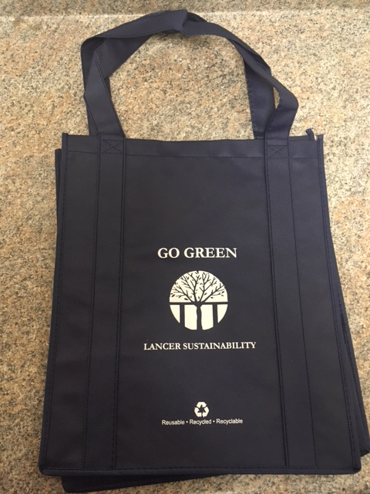
5 actions =bronze prize
Green Lancer
reusable bag

STEP 3: GET CERTIFIED!
Green Lancer Certified = prizes & happy planet

Start The Year off on a Green Leaf
Green Lancer Challenge

Sustainability Event Calendar
Spring 2018
January
Green Lancer kickoff event
February
RecycleMania benchmarking
March
Waste Audit
Summer Rayne Oakes Speech
Eco- April
Environmental Panel Discussion
Arbor Day Tree Planting
Climate Speaker
+More
May
Drop’n Swap
Follow the “Longwood University Office for Sustainability” on Facebook for the most up to date event information
Head to: longwood.edu/sustainability/get-involved/green-lancer/
Benefits:
-help the environment by saving resources and reducing Greenhouse Gas emissions
-create a greater culture of sustainability at Longwood University
-educate yourself and others about sustainable lifestyle options at Longwood
-win prizes from completing actions and attending events
Some possible prizes include:
-Pens -Dining coupons
-Reusable tumbler -Reusable bag
-Reusable travel eco-utensils
Green Lancer Challenge
Head to: longwood.edu/sustainability/get-involved/green-lancer to sign up
Signing up takes less than a minute!

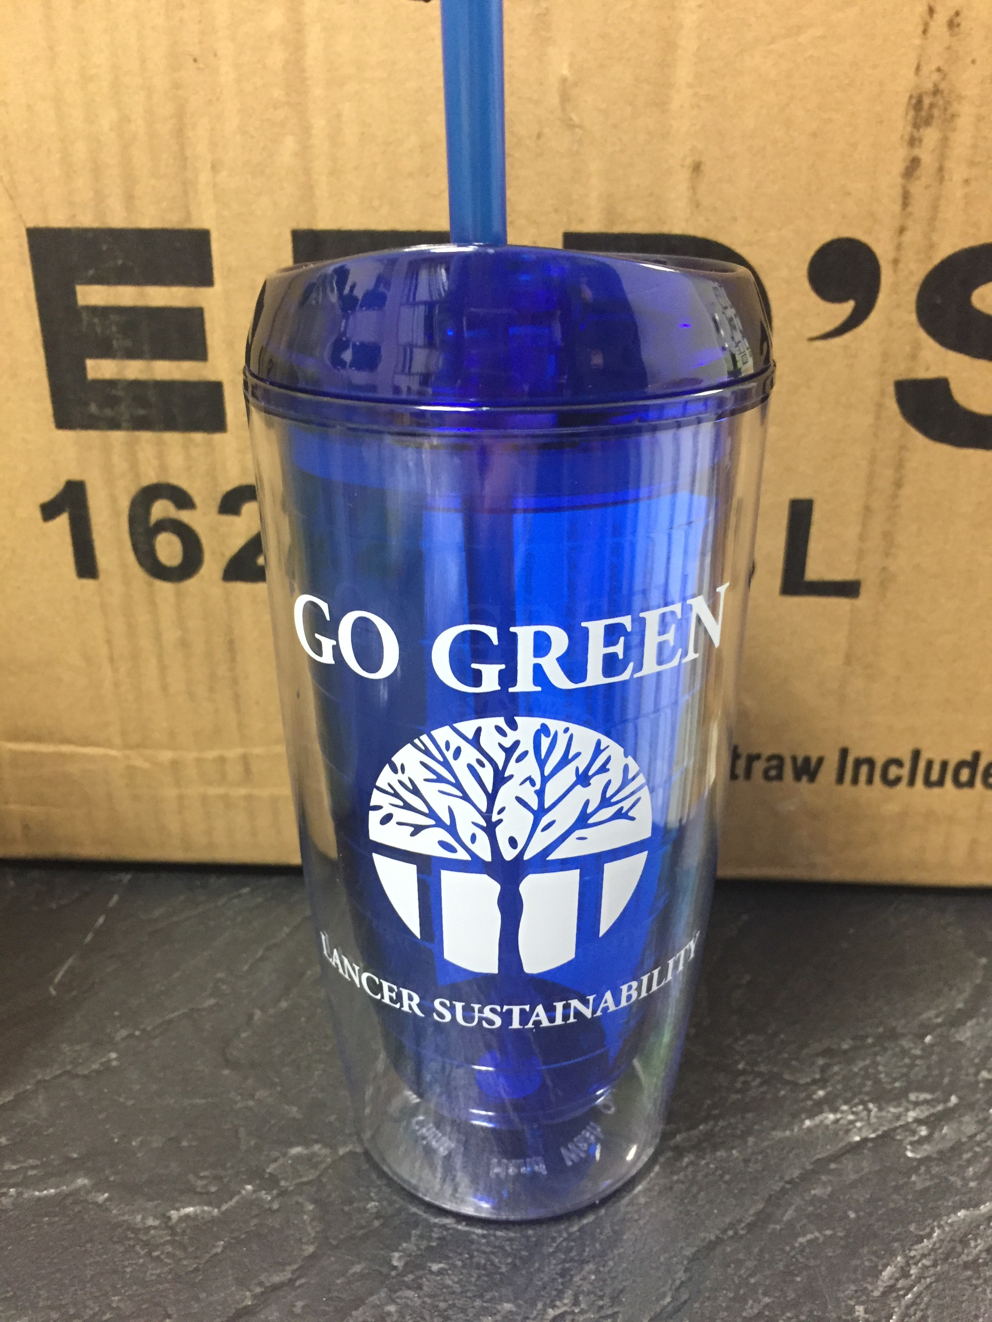
STEP 3: GET CERTIFIED!
10 actions= Green Lancer Certification /prizes

STEP 1: SIGN UP
Get a pen
STEP 2: TAKE ACTION
5 actions= bronze prize

