An Excessive amount of room left for an incredibly long thesis title in the case that a more concise title could not be achieved

Author Name
Department of Chemistry and Physics
Longwood University, 201 High Street, Farmville, VA 23909
Faculty Advisor: Dr. Thesis Advisor
April 29, 2020
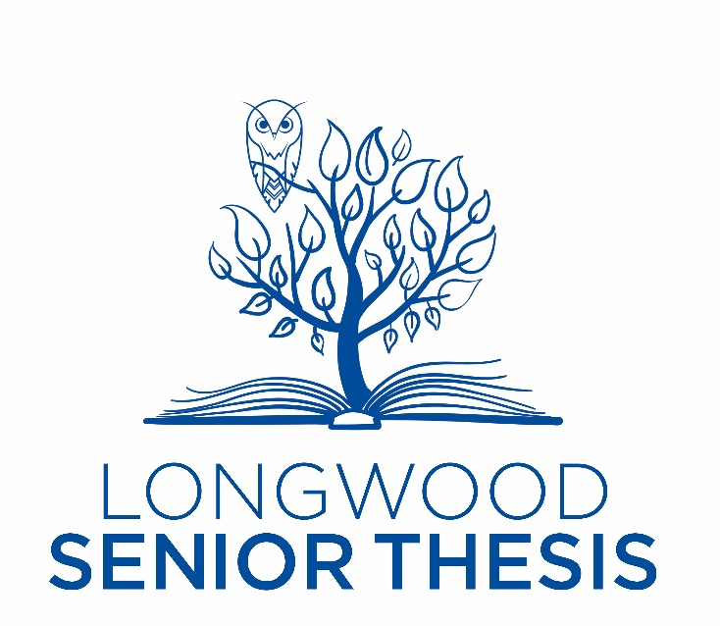
This senior thesis is submitted in partial fulfillment of the
requirements for

Honors in Chemistry

Committee Members: Dr. Benjamin Topham (Longwood University), Dr. Jonathan White (Longwood University), and Dr. Jason Pajski (University of Mount Olive).
An Excessive amount of room left for an incredibly long thesis title in the case that a more concise title could not be achieved
by
Author Name
This thesis has been read and approved by the following supervisory committee and submitted in its final draft to the Longwood Senior Thesis Committee in the conferment of Honors towards the degree of Bachelor in Chemistry.

Committee Members:

__________________________________________
Dr. Thesis Advisor (Longwood University)

__________________________________________
Dr. Committee Member (Longwood University)

__________________________________________
Dr. Committee Member (Longwood University)

__________________________________________
Dr. Committee Member (Not Longwood University)
Table of Contents
Abstract 4
Dedication 5
Chapter 1 6
Chapter 2 11
Chapter 3 15
Chapter 4 19
Conclusion 26
Methods 27
References 32

List of Figures:
Figure 1: 7
Figure 2: 8
Figure 3: 9
Figure 4: 12
Figure 5: 12
Figure 6: 13
Figure 7: 15
Figure 8: 19
Figure 9: 20

List of Schemes:
Scheme 1: 21
Scheme 2: 21
Scheme 3: 22
Scheme 4: 23
Scheme 5: 24
Scheme 6: 25

List of Tables:
Table 1: 17
Table 2: 23

Abstract
Include only an abstract on this page using your field of studies abstract guidelines.

Dedication
You may personalize a dedication to those that played a pivotal role in your getting through college, this thesis, life in general, etc.

